**Innovations/Impact:**

PyPlanScoring performs structure volume upsampling and dose trilinear interpolation, in order to improve the calculation accuracy on DVHs from any complex or small strucures. It was built using Python 3.x and open source packages.

**Key Results:**

* Built using only open source python packages
* High computation performance using [Numba compiler](http://numba.pydata.org/) targeting both CPU or NVIDIA/GPU without having to switch languages.
* Full DICOM RT parsing - IMRT, VMAT or proton IMPT.
* 3D dose extraction and trilinear interpolation
* Accurate DVH calculation
* Volume up-sampling with voxels up to 0.2 mm3
* Adaptive rasterisation

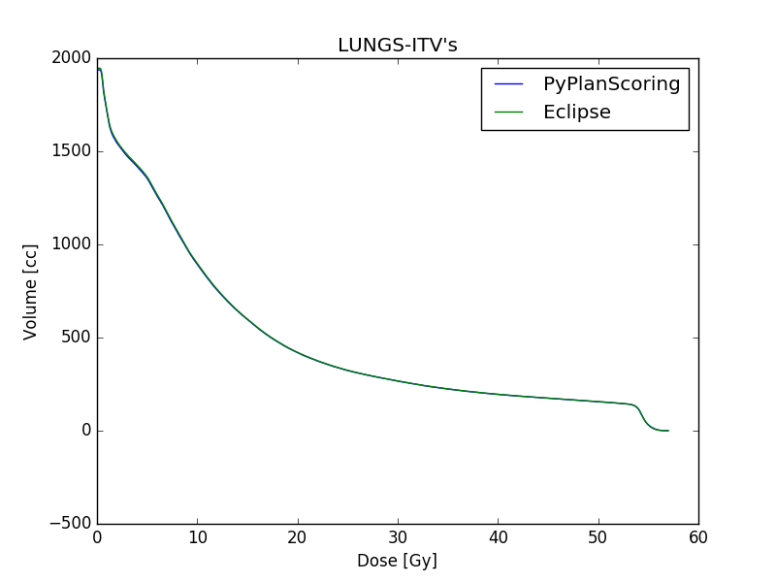  
Illustration 1: LUNG SBRT case - Lungs-ITV's- PyPlanScoring versus Eclipse

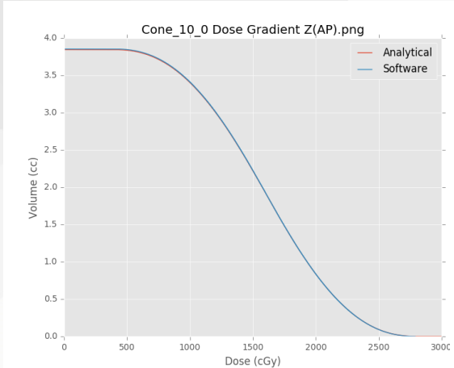  
Illustration 2: Absolute DVH comparison - voxel size (0.2 mm3)

  
Table 1: Difference % - DVH volumes - PlanIQ versus PyPlanScoring

  
Table 3: Test 2 - Calculated versus Analytical DVH - Clinical grid sizes

  
Table 2: Test 1 - calculated versus Analytical DVH - varying dose grid resolution.